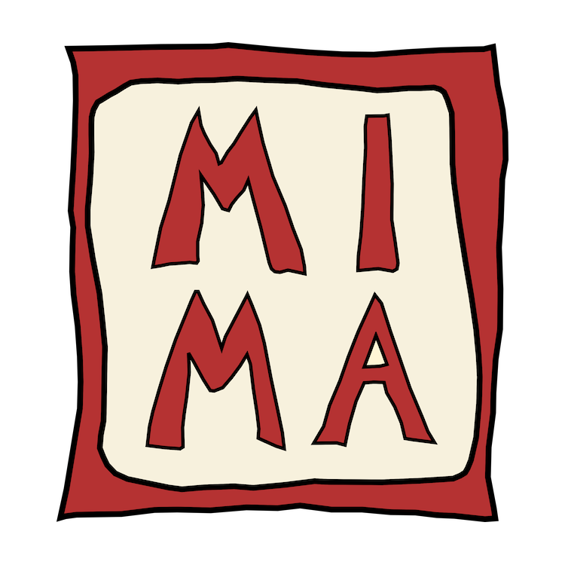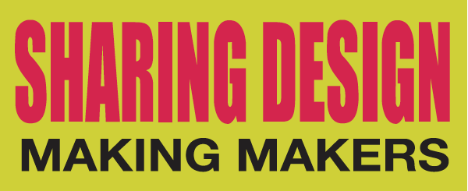

Call for “Making Makers”
Terza Edizione Sharing Design, 2–17 Aprile 2016
Fabbrica del Vapore, padiglione Messina 2
via Procaccini 4, 20154 Milano.

Surname

Name

Email

Website

Name by which you want to be mentioned

Registration date by Milano Makers 2016

Categories where you partecipate: product, fashion, either

Product name:
(it is important to match the caption to the attached image)

Product description max 5 words

The year of the design

Materials

